The Wishing Wellness station and the Wishing Well
Purpose – The Wishing Wellness initiative is intended to help staff in a variety of healthcare settings – hospitals, clinics, long-term care, home healthcare, hospice, and EMS – stay healthy during the often difficult and emotionally taxing work they do every day. The initiative provides healthcare workers (HCW) with a place where they can break away, pick a stress-relieving, resilience-building activity that can be done in the moment, and do it then and there. The goal is to provide HCWs with real-time tools to destress, relax, let go, and build resilience skills during the course of a stressful day. See printable version of this statement below.
Benefits - The benefits of using the Wishing Wellness initiative and its signature Wishing Well include the following:
- Pick the activity that best fits your need in the moment.
- Learn not only the stress-relieving, resilience building activity, but the “why” behind its effectiveness.
- Learn stress relieving, resilience-building skills that can be used anywhere, anytime (not just at work). This is a “take it with you,” skills building experience as well.
- Build a pattern of resilience building activity into each day, and by that develop a paradigm that limits stress activation and maximizes resilience.
- Have some fun each day!
- Create opportunity for individuals, small groups, or teams to use the Wishing Well regularly to build resilience and camaraderie together.
When you or a co-worker is having a difficult time, take a break and go to the well! See printable version of this statement below.
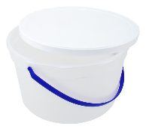
Wishing Well Container – Due to use in a medical setting, your container must be easy to clean. Using one that is easy to decorate like a well is handy. Minimum size for the container is 3 gallons.
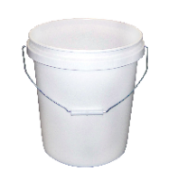
- “Cheese Balls” plastic jar (don’t empty the jar by yourself!)
- Plastic ice cream pail
- Popcorn tub (clean)
- Round or square waste basket
- Wooden ice cream maker bucket (with plastic cleanable liner)
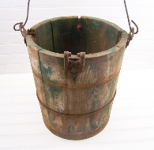
- 5-gallon storage pail
Decorate your container to look like a well, with a brick, stone, log or other motif. The decoration can be done on cardboard, printed paper, fabric, or glued materials and wrapped around the container. Or, simply place a “Wishing Well” sign on it!
- For decorating ideas, try Pinterest or just seach for wishing well decorations on Google.
- Some stores sell contact paper that looks like bricks.
- Four or five gallon buckets with lids can be purchased in bulk on Amazon and similar outlets. They are available at fleet and farm-type stores, home improvement stores, and even Walmart.
- If desired, you can put a “roof” on the well as long as it does not block access for those staff members with limited mobility. Adding the roof is optional, but if someone is handy or is married to a handy person, go for it!
- When done, the “wishing well” should be easy to access by any staff person, including staff with disabilities.
- Position on a low or standard height table or counter with enough room for the backdrop.
- See photo of a simplistic WW set-up below, along with more ornate options to inspire your well-building activities!
Backdrop – position against a wall or provide a backdrop such as a cardboard tabletop tri-fold presentation board (available at office supply stores). You might be able to repurpose a used presentation board by using the back side of it. Have enough room for posting several explanation documents and a comment board (see below).
Instructions - When you are feeling the tension or pressure on you, when you are facing or have just completed an exceedingly difficult task, or when the day “just ain’t makin’ it,” go the well!
- Sanitize your hands.
- Sign the guest book, if you want to and there is one.
- Reach into the well and choose a card – the are color-coded by area of focus (see chart).
- Read the activity, then turn the card over to read why this works for most people.
- Do the activity there or take it back to a quiet or private space if you prefer.
- Take a picture of the card with your phone for use at home or other location.
- When done, dispose of the card in the proper container (not back into the well) or place in the recycled card container if there is one.
- Make a note of it – write what you did and how it helped on a sticky note and post it on the comment board or wall.
- Enjoy the day!
Remember – you can go to the well as a group, too. You can also remind people who might be stressing out that they can use the Wishing Well. Tell ‘em to “Go to the well!”
Think about sending an email to a few people about how going to the well helped you today. See printable version of this statement below.
Hand sanitizing station - Be sure to have a hand sanitizing station for use by staff participants.
Suggestion box - Virtual suggestion/comment option – Consider placing a “Comment/suggestion box” at the Wishing Well station to collect new ideas, feedback, and other comments. Place a stack of comment papers with the box, and perhaps a connected pen for writing.
Formal/informal champions – A project like this one needs champions who will own it, maintain it, and promote it over time. These can be people who are assigned to it as a part of their job or volunteers who see the value and are willing to commit the time as a gift to their teams. Without champions for each station, the idea will struggle for survival. Who are your assigned and spontaneous champions?
Wishing Wellness Cards – There are four different colors to the cards in the Wishing Well. The green cards provide physical activities that help relieve stress and building resiliencel, the pink cards provide emotionally focused activities, the yellow cards provide more cognitive level activities, and the blue cards provide activities in the spiritual area of living. On the card masters the color of paper is indicated in fine print on the front side card master pages. Please use the right color paper to help folks choose the best option for their need that day.
Green – physical focus
Pink – social/emotional focus
Yellow – cognitive focus
Blue – spiritual focus
Receptacle – the cards are disposable, please have a suitable trash receptacle at the station.
Comment board – The comment board is intended to give people a chance to tell their Wishing Wellness story as a way of encouraging others in their own trips to the well. If using sticky notes, place four colors of note pads and several pens at the station, and directly adjacent to the comment posting area. Encourage staff to write about their experience and put it up on the board.
Stop by several times each week and take a picture of some of the comments to send out in an email to your teams as a reminder to “go to the well.”
Your IT/Tech people can also set up a type of digital comment board on which people can post their experiences.
Other ideas – Consider such things as having individually-wrapped treats of snacks (think healthy) at the station from time to time. Make it fun to go there. Toss a couple of Caribou Coffee cards in the well from time to time as a freebie for someone.
Move the station around the area if it is a large space, making it easy for everyone to “go to the well.” In large staff environments like hospitals or larger clinics, consider having multiple Wishing Wellness stations conveniently located.

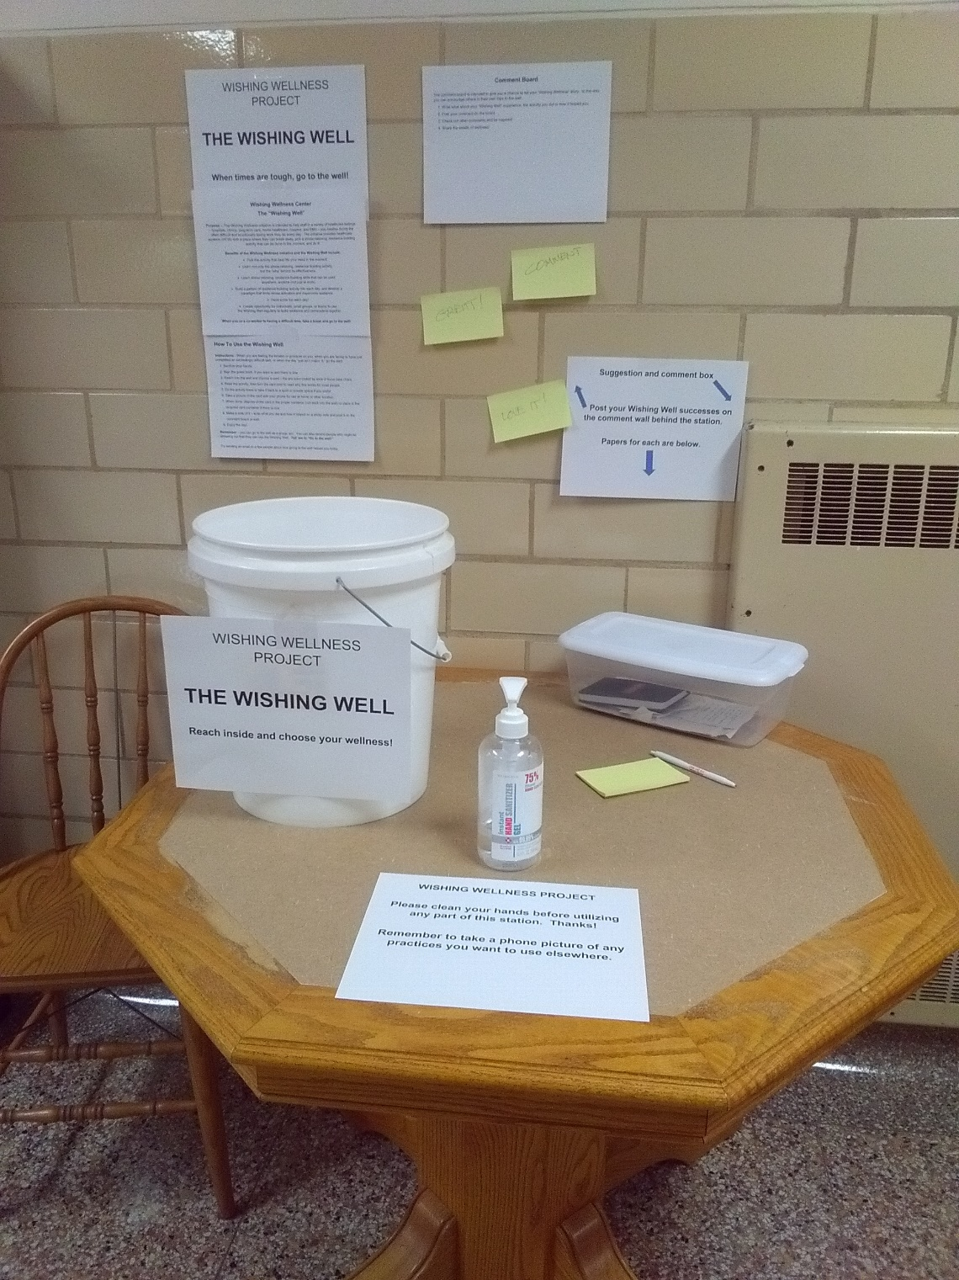
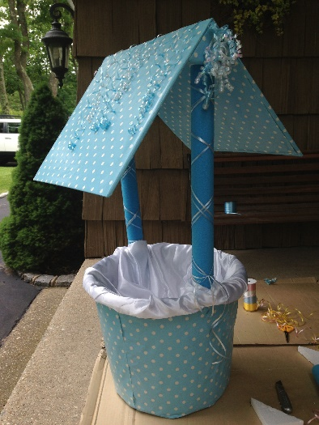
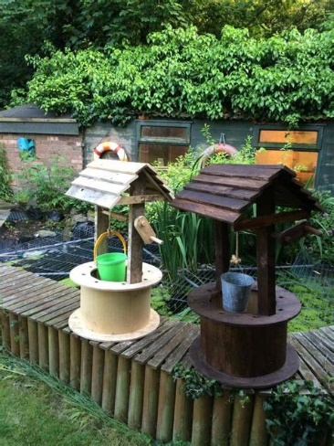
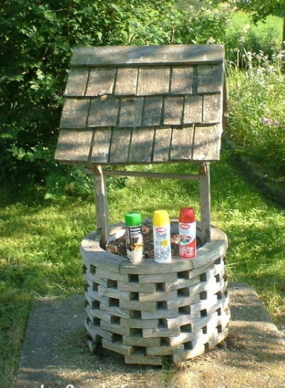
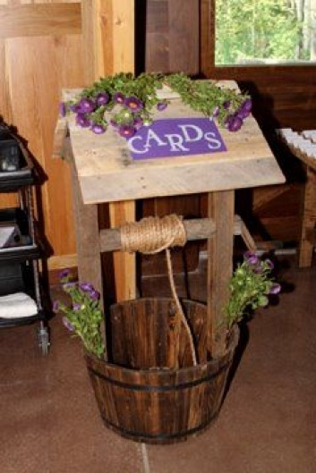
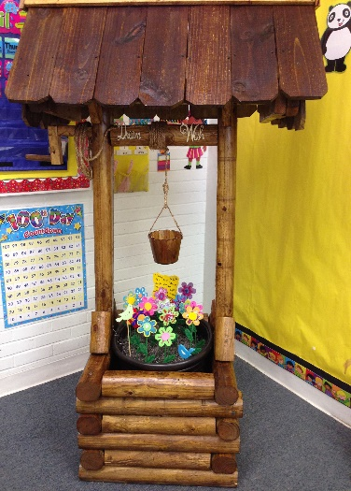

Wishing Wellness Center
The “Wishing Well”

Purpose – The Wishing Wellness initiative is intended to help staff in a variety of healthcare settings – hospitals, clinics, long-term care, home healthcare, hospice, and EMS – stay healthy during the often difficult and emotionally taxing work they do every day. The initiative provides healthcare workers (HCW) with a place where they can break away, pick a stress-relieving, resilience-building activity that can be done in the moment, and do it!

Benefits of the Wishing Wellness initiative and the Wishing Well include:
- Pick the activity that best fits your need in the moment.
- Learn not only the stress-relieving, resilience building activity, but the “why” behind its effectiveness.
- Learn stress relieving, resilience-building skills that can be used anywhere, anytime (not just at work).
- Build a pattern of resilience building activity into each day, and develop a
paradigm that limits stress activation and maximizes resilience.
- Have some fun each day!
- Create opportunity for individuals, small groups, or teams to use the Wishing Well regularly to build resilience and camaraderie together.

When you or a co-worker is having a difficult time, take a break and go to the well!
How To Use the Wishing Well

Instructions - When you are feeling the tension or pressure on you, when you are facing or have just completed an exceedingly difficult task, or when the day “just ain’t makin’ it,” go the well!
- Sanitize your hands.
- Sign the guest book, if you want to and there is one.
- Reach into the well and choose a card – the are color-coded by area of focus (see chart).
- Read the activity, then turn the card over to read why this works for most people.
- Do the activity there or take it back to a quiet or private space if you prefer.
- Take a picture of the card with your phone for use at home or other location.
- When done, dispose of the card in the proper container (not back into the well) or place in the recycled card container if there is one.
- Make a note of it – write what you did and how it helped on a sticky note and post it on the comment board or wall.
- Enjoy the day!
Remember – you can go to the well as a group, too. You can also remind people who might be stressing out that they can use the Wishing Well. Tell ‘em to “Go to the well!”

Try sending an email to a few people about how going to the well helped you today.

Comment Board

The comment board is intended to give you a chance to tell your “Wishing Wellness” story. In this way, you can encourage others in their own trips to the well.
- Write what about your “Wishing Well” experience, the activity you did or how it helped you.
- Post your comment on the board.
- Check out other comments and be inspired!
- Share the wealth of wellness!

WISHING WELLNESS PROJECT

THE WISHING WELL

Reach inside and choose your wellness!

WISHING WELLNESS PROJECT

Please clean your hands before utilizing any part of this station. Thanks!

Remember to take a phone picture of any practices you want to use elsewhere.

Suggestion and comment box

Post your Wishing Well successes on the comment wall behind the station.

Papers for each are below.

Physical S=Stretching, MP=Mindfulness/Presence, SC=Self-care, PG=Positivity/Gratitude, SR=Stress Relief, RS=Resilience/Strength
Action | Type | Do This | Benefits
1. Seated Hamstring Stretch | S | Lock/stabilize your hip joints, and slowly stretch toward your toes. Hold for 30 seconds each stretch while breathing deeply and slowly. Do not bounce. | Improves lower back, hip, leg, and knee flexibility and movement. Focuses mind and breathing to lower stress. Reduces chances for injury.
2. Standing Back Extension | SC | Begin in a standing position.  Place your hands on the back of your hips (or the small of your back).  Inhale, keeping a neutral chin. Slowly bend backwards until you feel a gentle stretch in your chest and back.  Hold for a few seconds and release.  Repeat as desired. | Use this exercise to strengthen the back while relieving tension.
3. 4-7-8 Breathing | MP | Close your eyes and clear your mind.  Breathe in slowly, counting to 4 seconds while you inhale.  Then, hold your breath for 7 seconds.  Finally, breathe out slowly and softly, counting 8 seconds while you exhale.  Repeat 3 times. | Use this practice to reduce anxiety or get to sleep.
4. Chest Opener | S | Stand tall or sit upright.  Begin with arms in front of the body (as if holding a big ball).  Inhale and open the arms, squeezing your shoulder blades together.  Exhale as you close your arms in front of your body.  Repeat for 8 slow breaths. | Use this stretch to open the chest allowing for our shoulders and back to build strength for better posture while relieving tension.
5. Standing Hamstring Stretch | S | In a standing position, extend your right leg out with heel to the floor, bending the left knee.  Place your hands on the left leg for balance and then gently lower your hips towards the floor.  Hold and feel the gentle stretch in your right hamstring. Right toes can point up towards the ceiling, or you can flatten your right foot towards the floor for an increased stretch.  Gently release and shake it out.  Extend your left leg out with heel to the floor, bending the right knee.  Hold and feel the gentle stretch in your left hamstring. Left toes can point up towards the ceiling, or you can flatten your left foot towards the floor for an increased stretch.  Gently release and shake it out. | Use this practice to increase flexibility and range of motion while relieving tension.
6. Standing Heel Lifts | SC | Heel lift exercises help strengthen the calf muscles.  Strong calf muscles are beneficial for daily activities, such as walking, running and jumping.  Stand with your feet about shoulder-width apart. Have a chair or the wall nearby for support if you need it.  Lift your heels off the floor so that you’re standing on the balls of your feet.  Slowly lower your heels to the floor. Control is important for strengthening your muscles.  Option: arms can rest to the sides OR you can lift them parallel to the floor as you raise and lower your calves.  Do 20 to 30 slow and controlled lifts. | Use this exercise to strengthen the calf muscles in support of daily activities while relieving tension.
7. Take Care Of Your Back | SC | Our backs are an important function of daily activities. We need to focus on our back/core strength to help increase stability, improve daily function, and decrease the potential for injury.  Standing back extension  Begin in an upright position, standing with your feet shoulder width apart and flat on the floor.  Place your hands on your hips and slowly arch your torso, shoulders and head backward as you push your hips forward.  Hold briefly and return to the starting position.  Repeat this activity up to 10 minutes.  Remember to go slow and avoid bending your knees when arching back.  This is a great exercise to practice when bending or sitting for extended periods of time. | Use this exercise to strengthen the back while relieving tension.
8. Eagle Arms | S | Seated or standing, the eagle arms pose opens up the upper back, deltoids, and shoulders.  Start by raising your arms out in front of you with a 90 degree bend in your elbow (fingers pointed to the sky).  Place your right arm into the elbow crease of your left arm (to form an X). Bend your elbows and intertwine your forearms. If able, press your palms together.  Lift your elbows to shoulder level and press them forward, separating your shoulder blades away from each other.  Breathe and hold for 10 to 30 seconds, release and shake out.  Switch sides, left arm into the elbow crease of your right arm (to form an x). Bend and intertwine the forearms. Lift / hold and then release.  Alternative: If it’s tough to cross your arms, give yourself a big hug and work on reaching for the opposite shoulders. Place your hands as far around the shoulders as you can— the tighter you hug, the more of a stretch you will feel. | Use this stretch to open the shoulders and upper back while relieving tension.
9. Spinal Twist | S | Bring your hips towards the edge of the chair. Sit up tall.  Inhale and twist your body to the right.  Exhale, place your hands on the arm rest of the chair or the seat cushion of the chair.  Hold for an inhale and exhale.  Release body back to front.  Inhale and twist your body to the left.  Exhale, place your hands on the arm rest or the seat cushion of the chair.  Hold for an inhale and exhale.  Release body back to front.  Repeat 2 more times on each side. | A gentle twist creates stimulation in blood circulation and tension release in the lower back. Focuses mind and breathing to lower stress. Reduces chances for injury.
10. Windmill Stretch | S | Stand tall with your feet wider that hip width apart and your arms to your side.  Inhale, swing your arms out to the side and then above your head. Like a rainbow.  Exhale, lower the arms down to your side and into a gentle squat.  Cross the arms in front of your chest.  Inhale and repeat 8 to 10 more times. | Use this exercise as a way to warm up your body from shoulders to feet and to build energy while relieving tension.
11. Stand Like A Tree | MP | Stand with your feet parallel and at least shoulder’s width apart. Close your eyes, if you choose.  Keep your head floating above your body, chin tucked, and spine straight.  Rest your hands at your side or place them over your navel.  Sink all of your body’s weight and tension into your feet (without collapsing your posture), allowing it to be absorbed into the ground.  To support this grounding process, imagine roots growing out the bottom of your feet, extending deep into the ground beneath you.  Ground and pause for 5 slow breaths. When finished, slowly open your eyes, feeling refreshed and ready for the day. | Use this exercise to increase strength and balance while grounding your feet to the floor while relieving tension.
12. Forward fold | S | Stand tall or sit upright.  Inhale deep breath, raise the arms up to the ceiling.  Exhale, slowly lower your chest towards your thighs. *You do not need to bring your hands to the floor.  Allow your neck to relax.  Hold for an inhale and exhale, and then gently raise your body back to standing or sitting upright position.  Repeat as needed. | Use this exercise to release tension in the back while stretching from our feet all the through to our shoulders while relieving tension.
13. Arms Up & Smile | PG | Stand tall with your feet below your hips  Inhale and reach your arms up to the sky.  Hold for an inhale and exhale.  Slowly lower your arms to your side.  Now, add a smile! Each time you raise your arms up to the sky – SMILE!  Our brains don’t know the difference between a real and forced smile. In fact, the forced and real smile release the same ‘happy chemicals’.  Repeat 3 to 5 times. | Use this exercise to strengthen the back and stretch the chest and shoulders while relieving tension.
14. Standing Child's Pose | S | Child’s pose is a restorative yoga position that involves a lower-body stretch.  Stand arm’s length away from the desk or wall, feet shoulder width apart.  Bend at hips, reach forward and rest palms on the edge of desk or on the wall at waist height.  While keeping your head aligned with your spine, lower your chest until you feel a slight stretch through the shoulders and back.  Keep arms straight and hold (and breathe!) for 15 to 30 seconds.  Repeat as needed. | Use this movement to pause, rest, and center while stretching the spine, hips, and thighs while relieving tension.
15. 10,000 Steps | SR | If you are a Fitbit junkie, work to get your 10,000 steps in at least 3 days per week.  You can do this in short sections on breaks, lunch time, before and after work.  Park further from the door at work, shopping, church.  If you do not use Fitbit or a similar fitness tracker, think about getting 4 miles or more at least 3 day each week. | Stress relief, weight loss, overall strength, mind-strengthening, cardio work if you walk fast.
16. Deep Breathing | MP | In a seated position, close your eyes and clear your mind.  Inhale slowly, for a count of 8, 7, 6, 5, 4, 3, 2, 1  Exhale slowly, for a count of 8, 7, 6, 5, 4, 3, 2, 1  Inhale slowly, for a count of 8, while raising your arms above your head.  Exhale slowly, for a count of 8, while lowering your arms back down to your sides.  Repeat for as long or as often as you choose. | Use this practice to reduce anxiety or get to sleep.
17. Pursed Lip Breathing | MP | Relax your neck and shoulders.  Keeping your mouth closed, inhale slowly through your nose for 2 counts.  Pucker or purse your lips as though you were going to whistle.  Exhale slowly by blowing air through your pursed lips for a count of 4.  Practice this breathing pattern 4 to 5 times a day. It may be especially useful during activities such as bending, lifting, or stair climbing. | Use this practice to reduce anxiety, to focus, and feel re-energized.
18. Cat/Cow (seated or standing) | S | Stand up or sit tall: Place your hands on your knees.  Inhale and lift chest: Inhale, lifting/opening your chest while pressing your hips behind you. (Cow) This helps stretch the muscles along the front of your chest.  Exhale and round: As you exhale, pull your belly in toward your spine, rounding your back as if rounding over a beach ball in front of you. (Cat) If it’s comfortable, lower your chin toward your chest.  Alternate between cow and cat for three to five full breaths.  This pose can help improve posture and balance and back pain. The benefits of this synchronized breath movement will also help you relax and ease some of the day’s stress. | Use this movement to improve our posture and balance, to stretch through the core of our bodies, neck, and spine while relieving tension.
19. Ankle Circles | SC | While seated, cross your right leg over your left, resting your right calf on your left thigh.  Slowly rotate your right ankle clockwise in big circles.  Next rotate the same ankle again, this time counterclockwise.  Then switch legs and repeat. | To increase mobility and stability in our ankle joints while relieving tension .
20. Standing Chest Stretch | SC | Begin with your arms at a “T” and inhale.  Exhale, move your arms behind your (squeezing your shoulder blades together).  Hold for an inhale and exhale.  Relax. Feel free to repeat 2 to 3 times. | Use this stretch to open the chest allowing for our shoulders and back to build strength for better posture while relieving tension .
21. Hip Extension | S | Stand tall and place hands on a table or chair to help with balance.  Begin with all your weight on the left leg. Keeping the right leg straight, tighten the gluteal muscles so that the leg extends behind you about 12 inches.  Hold and then return to start.  Switch to having all your weight on the right leg. Keeping the left leg straight, tighten the gluteal muscles so that the leg extends behind you about 12 inches.  Hold and return to start. | Use this stretch to open the hip to build flexibility while relieving tension .
22. Hip opener | S | Begin in a seated position.  Raise your right ankle to the left knee.  Place your right hand on the right knee and your left hand on the left ankle. Slowly lean your body forward.  Relax and lower your right leg to the ground.  Raise your left ankle to the right knee.  Please your left hand on the left knee and your right hand on the right ankle. Slowly lean your body forward.  Relax and lower your left leg to the ground.  Breathe slowly and deeply. | To allow our hips to gain greater flexibility and strength. Improves lower back, hip, leg, and knee flexibility and movement. Focuses mind and breathing to lower stress. Reduces chances for injury.
23. Leg Extensions | SC | Leg extensions target the quadriceps muscles. Strong quads are important for walking, squatting, and good posture.  Sit in a chair. Plant your feet on the floor, hip-width apart.  Straighten your back.  Extend your right knee to lift your right leg.  Controlled, slowly return to starting position.  Start with two sets of 10 to 12 reps. Repeat with the left leg. | Use this exercise the build strength and balance in our legs while relieving tension.
24. Neck Stretch and Breathing | SR | Sit upright.  Slowly lower your left ear to the left shoulder. Hold for a slow inhale and exhale.  Gently roll head down and lowering your chin to chest. Pause for a moment.  Inhale, roll head to the right and hold right ear to the right shoulder. Hold for a slow inhale and exhale.  Gently roll head down and lowering your chin to chest. Repeat to the left and then again to the right. | Use this practice to release stress and tension from your neck and shoulders while relieving tension.
25. Seated Forward Fold | S | Sit comfortably in the chair with your back straight.  Inhale, raise your arms up to the ceiling.  Exhale, lower the arms down to your side, relax your neck and lower your chest towards your thighs.  Inhale and exhale hold in the forward fold position.  Exhale and return to your upright position. Repeat 2 to 3 more times. | Use this stretch to lengthen your spine, stretching from the calves to the hamstrings while relieving tension.
26. Shoulder Blade Squeeze | S | Standing or sitting, create a 90 degree bend in the elbow. Keeping hands shoulder width apart.  Gently squeeze the shoulder blades together to activate the upper and mid back muscles.  Hold and then return to starting position.  Repeat 3 to 4 times. | Use this stretch to open the chest while improving or focusing on your posture while relieving tension.
27. Shoulder Stretch | S | In a seated or standing position, place your right arm across your chest.  Grab the right arm, above the elbow, with your left hand.  If you can, pull your right arm a bit closer into the chest with your left hand.  Hold for a moment.  Gently release and repeat with your left arm.  Grab the left arm, above the elbow, with your right hand.  If you can, pull your left arm a bit closer into the chest with your right hand.  Hold for a moment.  Gently release. Repeat on each side as needed. | Use this stretch to loosen and increase the flexibility/range of motion of the shoulder while releasing tension.
28. Shoulder/  Back Stretch | S | Seated or standing position.  Interlace your fingers and turn palms facing away from you. Raise arms shoulder height.  Gently extend the arms in front, keeping the fingers interlaced.  With the arms straight in front, gently press the spine back towards the chair (rounding the back). Feeling a gentle stretch in the shoulders.  Hold for 10 seconds and release. Feel free to repeat 2 to 3 more times. | Use this stretch to loosen and increase the flexibility/range of motion of the shoulder and back while releasing tension.
29. Side Lunge | SC | Begin in a standing position  Step your right foot out to the side of your body, greater than shoulder width apart.  Bend your right knee into a gentle side lunge.  Return to the center.  Step your left foot out to the side of your body, greater than shoulder width apart.  Bend your left knee into a gentle side lunge.  Return to center.  Repeat 2 to 3 more times on each side. | Use this exercise to strengthen your inner and outer thigh and to increase stability and balance by increasing the body's ability to move more freely from side to side while relieving tension.
30. Side Stretch | S | Stand tall with your feet wider that hip width apart and your arms to your side.  Inhale, reach your right arm up and over your head. Hold for a slow inhale and exhale.  Lower your arm to your side.  Inhale, reach your left arm up and over your head. Hold for a slow inhale and exhale.  Lower your arm to your side.  Repeat one more time on each side. (2 to 3 more times ideally) | Use this stretch to open the rib cages and stretch through the sides of our bodies while relieving tension.
31. Torso Stretch | S | Stand tall or sit upright.  Clasp hands together and raise them above your head toward the ceiling. Reach as high as you can, pressing palms up.  Gently twist your chest to the right and then to the left.  Lower your hands slowly while exhaling.  Repeat twice, being mindful of breathing. | Use this exercise to stretch through the core of our bodies while relieving tension.
32. Wrist Stretches 1 | SR | How to perform a self hand and wrist massage:  begin by placing your fingers over your wrist, as if you’re taking your pulse, and apply a side to side pressure across your wrist.  move to the heel of your palms and start applying pressure in a small circular motion, working your way from the pinky finger side and moving towards your thumb side.  next, grasp the web of tissue that connects your thumb to the rest of your fingers and gently move it up and down.  then apply pressure by using a small circular motion to the muscles at the base of your fingers.  next move up each finger using small circular strokes.  once you reach your finger tip, gently pull the finger to stretch the joint.  perform on both sides. | Use this exercise to improve circulation of the blood within our wrist and hand while also relieving any tension or soreness.
33. Wrist Stretches 2 | S | In a standing or sitting position, place the palms of your hands together.  Elbows should be raised out to the side, with the hands in front of the chest.  Keeping your palms pressed together, slowly press the heels of your hands towards the floor, feeling a gentle stretch on the back side of the wrist.  Hold for 10 seconds and then release. Repeat as needed. | Use this exercise to reduce injury and increase flexibility of our wrist joints while relieving tension.
34. Neck Massage | SR | Stress builds up and we often hold it in our shoulders and neck.  One way to help release that tension is to massage it out.  Bring your shoulders up to your ears and drop them down 2-3 times.  Straighten your neck and back.  Rub your hands together to warm them.  Locate the painful areas on your neck.  Press firmly with your fingers. Gently move your fingers in circular motions.  Repeat in the opposite direction. | Use this practice to release stress and tension from your neck and shoulders while relieving tension.
35. Shoulder Self-Massage | SR | Prior to practicing, please sanitize your hands. Remember to sanitize again after completing.  Shoulder self massage technique:  Position the fingers of your right hand over your right shoulder (your upper trapezius will be underneath your palm).  Squeeze your upper trapezius three times and then roll your fingers over the muscle starting from the outside and moving towards the base of your neck.  Repeat on your left side. | Use this exercise to release tension and muscle soreness while relieving tension.
36. Dance (Like no one’s watching) | SR | Dancing and movement is important for our minds AND our bodies.  Take a moment today, find your favorite song and dance!  You will be surprised how well you feel by positively releasing your stress and allowing your endorphins to flow through your body! | Dancing gives us energy, evokes happy thoughts, helps us share our emotions in an artistic format while relieving tension.
37. Diaphragmatic Breathing | SR | To begin:  Sit in a comfortable chair.  Place one hand on the belly and the other on the upper chest.  Breathe in through the nose, focusing on the belly rising.  Breathe out through pursed lips, focusing on the belly lowering.  Repeat for 8 breaths or longer. | Use this breath activity to reduce anxiety and stress while allowing our minds to relax.
38. Tapping | SR | What is tapping?  According to the Tapping Solution, “tapping is a combination of Ancient Chinese Acupressure and Modern Psychology that works to physically alter your brain, energy system, and body all at once.”  Tapping is useful during stressful times to help you work through anxiety, fear, negative emotions, or even challenges that are bothering you.  Start by placing your fingertips on the top of your head. Tap in that space 5 to 7 times and then move to the eyebrow.  Keep going through the points within the diagram to the right and finish off with your hand.  Tapping allows you to focus on your anxiety, stress, or challenge by accepting and resolving the emotions. The goal is to tap into the energies within your body to flow positive energy into your system, allowing your mind and body to heal.  For more information about tapping, visit: https://www.thetappingsolution.com/blog/what-is-tapping/#:~:text=Tapping%20is%20a%20combination%20of,a%20wide%20range%20of%20emotions. | Use this practice to dissipate anxiety.
39. Bundle n’ Trundle | SC | Get out of the building for a moment and enjoy the rain, snow, or other beauties of being outside for ten or fifteen minutes. | Getting into natural settings has been shown to improve mood and reduce stress.
40. Heal Lifts | SC | Heel lift exercises help strengthen the calf muscles.  Strong calf muscles are beneficial for daily activities, such as walking, running and jumping.  Stand with your feet about shoulder-width apart. Have a chair or the wall nearby for support if you need it.  Lift your heels off the floor so that you’re standing on the balls of your feet.  Slowly lower your heels to the floor. Control is important for strengthening your muscles.  Option: arms can rest to the sides OR you can lift them parallel to the floor as you raise and lower your calves.  Do 20 to 30 slow and controlled lifts. | Use this exercise to strengthen the calf muscles in support of daily activities while relieving tension.
41. Chair Yoga: Triangle Pose | S | In a standing position, begin with your feet wider than hip width apart.  Hinging at your hips, slowly lower your right hand to the base/seat of your chair. Keep your chest facing forward, do not face your chest towards the floor.  Slowly raise your left hand up to the ceiling. Keeping your chest facing forward.  Pause here for a brief moment and then lower your left arm down, raise your body back to the upright position.  Switch sides. Begin with use of left hand. Repeat the set. | Facilitates the opening of the shoulders and chest while providing a stretch to our hips, hamstrings, and groin while relieving tension.
42. Hand Stretches | SR | Begin by creating a fist with each hand.  Squeeze and then release.  Repeat x 2.  Now, open your hands.  Using your thumb as the “base” point.  Tap each finger on your thumb, creating the “ok” sign.  Move back and forth with your fingers to your thumb.  Cycle one (pointer, middle, index, pinky and back) – inhale (go slow)  Cycle two = exhale (go slow)  Repeat x 2. | Use this exercise to improve circulation of the blood within our wrist and hand while also relieving any tension or soreness while relieving tension.
43. Any Exercise | SR | Take breaks in the day to stop working and exercise. Work hard enough to elevate heart-rate and breathing. Try to exercise at least 20 minutes several times in your overall day. | Studies show that people who exercise more increase their levels of happiness along with their overall health.
44. The Big Bear Hug | SR | Start by giving yourself a big hug and work on reaching for the opposite shoulders. Place your hands as far around the shoulders as you can— the tighter you hug, the more of a stretch you will feel. | Use this stretch to open the shoulders and upper back while relieving tension. Seated or standing, this stretches the upper back, arms, and shoulders.

Social/Emotional S=Stretching, MP=Mindfulness/Presence, SC=Self-care, PG=Positivity/Gratitude, SR=Stress Relief
Action |  | Do This | Benefits
1.  Speak Thanks 1 | PG | Find at least three people right now who deserve a thank you and give them one. Be specific with the why. | Gratitude expressed is one of the most healthful practices we can practice daily. It is highly effective in releasing stress and building resilience.
2.  Speak Thanks 2 | PG | Find those people who serve the team without many thanks, and thank them for their service (cleaners, cooks, receptionists, etc.) | Gratitude expressed is one of the most healthful practices we can practice daily. It is highly effective in releasing stress and building resilience.
3. Write Thanks 1 | PG | Write down at least ten things that have happened today for which you are grateful. Keep the paper and look at it or add to it later. | Gratitude expressed is one of the most healthful practices we can practice daily. It is highly effective in releasing stress and building resilience.
4. Write Thanks 2 | PG | Write a “Thank You” Sticky note or two, and place it the recipients will find them. | Gratitude expressed is one of the most healthful practices we can practice daily. It is highly effective in releasing stress and building resilience.
5. Build Your A.R.K. | PG | Do one or two “Acts of Random Kindness” to people right now – deliver a chocolate, a coffee, or note of encouragement, invite to your table, etc. | Initiating prosocial activity is one of the most healthful practices we can practice daily. It is as effective as gratitude in releasing stress and building resilience.
6. Build a Bigger A.R.K. | PG | Find a partner and plan a simple “Act of Random Kindness” to do for a coworker or for your team. Plan it and work your plan. | Initiating prosocial activity is one of the most healthful practices we can practice daily. It is as effective as gratitude in releasing stress and building resilience.
7. 3 Good Things 1 | PG | Write or speak aloud three things for which you are grateful right now. | Gratitude expressed is one of the most healthful practices we can practice daily. It is highly effective in releasing stress and building resilience.
8. A Good Laugh | SR | Think of or read a funny story, one that will make you laugh out loud. | A good laugh has great short-term effects. Laughing stimulates your heart, lungs and muscles, and releases endorphins in your brain. It soothes tension and can relax your stress.
9. Share a Laugh | SR | Spend time with friends who make you laugh, sharing funny stories or jokes with those around you. | A good laugh has great short-term effects. Laughing stimulates your heart, lungs and muscles, and releases endorphins in your brain. It soothes tension and can relax your stress.
10. Mindful Movement | SR | Focusing on intentional movement – Yoga, a climbing wall, or others. | Studies show structured breathing, controlled movement, and focus. This combination is effective in reducing stress and increasing optimism.
11. Mindful Focus on Your Activities | SR | Look for points in your day where you can practice cultivating your attention, such as mindfully eating your dinner by engaging your senses to notice the taste, aromas and textures of each dish. Or try focusing on your breath, noticing the coolness of the air as you inhale and the warmth on your exhale. Can you feel the rise and fall of your chest with each breath? | Focus on activities has been shown to reduce distractive thoughts and ruminations on difficulties. It reduces anxiety, “what if” thinking, and tension.
12. Be Nicer | PG, SR | Be kind to people you interact with in the course of your day. Help someone with a heavy load. Run an errand for your sick neighbor. Give a co-worker a boost with a thoughtful compliment. | Being kind and/or generous activates your pleasure-reward system in the brain. And it can be contagious.

Cognitive S=Stretching, MP=Mindfulness/Presence, SC=Self-care, PG=Positivity/Gratitude, SR=Stress Relief, RS=Resilience/Strength
Action | Type | Do This | Benefits
- 3 Good Things 2 | PG | Take a moment at the end of this day to pause and reflect.  What three good things happened today?  Write them down  Reflect on why and how it impacted you.  “The real gift of gratitude is that the more grateful you are, the more present you become.” – Robert Holden | Use this practice to reflect upon your day and the experiences that impacted you.
- 3 Good Things 3 | PG | Recall three inspirational actions or qualities that you saw in other people today  Write them down  Reflect on how that impacted you. | Use this practice to reflect upon your day and the experiences that impacted you.
- Let It Go 1 | SR | Picture in your mind all of the difficult things of the last hour or shift, place them into your hands, and slowly open your hands and turn them over. Say, “I let you all go now.” Repeat if needed. | Use this to draw attention to your physical self, letting go of anxious thoughts and emotions.
- Follow Your Breath | SR | Close your eyes and clear your mind.  As you inhale slowly, observe the air as it enters your nose and goes into your lungs, filling your lungs completely.  On the exhale, follow the air leaving your lungs and exiting your nose or mouth.  Slowly repeat up to 1 minute. The key is to observe the breath instead of forcing it with your mind. | Use this practice to reduce anxiety or get to sleep while relieving tension.
- Positive Affirmations 1 | PG | Positive affirmations are expressions of love and kindness we can say to ourselves or with others to increase our resiliency and set a change of path.  Today, practice the following positive affirmations:  I am strong.  I am here to make a positive change today.  I am an amazing person.  Today I will walk through my fears. | Use this practice to build confidence and emotional strength while relieving tension.
- Recognizing Positive Moments | PG | Take a moment to think about something positive that has happened over the past day or even few days.  How did your body react? Imagine if you took time each day to recognize the positive moments. Think of this process as “HEAL”.  Have a positive experience (notice and pay attention to it)  Enrich it (Give the experience energy by making it important as possible)  Absorb and appreciate it (The experience is part of you)  Link it to your current life (You can return back to this moment, even during difficult times).  Other examples of ways to create positive emotions: humor, do things you enjoy doing, and get out in nature. | Use this activity to reflect on the good things and making note of how they impact our emotions.
- Grounding Hands and Feet | MP | Sit at the edge of your chair. Place your feet directly below your knees.  Bring your hands to the table, arm rests on your chair, or your lap shoulder-width apart, palms facing down. Press the center of your palms into the table, arm rests, or lap, and stretch out through your fingers.  Squeeze your shoulder blades into the body and down toward the tailbone. Feel your feet melting into the floor.  Hold and breathe.  Finally, relax. | Use this to draw attention to your physical self, letting go of anxious thoughts and emotions.
- Energetic/Stress Relief Breathing | SR | Sit comfortably. Close your eyes.  Sit for this one because the breath work may impact your head = becoming a bit light headed while standing.  Keeping your mouth closed, breath in through your nose as deep as you can.  Open your mouth, purse your lips, and as you exhale, the sound is similar to a “hah or who”.  Repeat for 5 more breaths.  Helpful if you need to take a quick breath between patients, or to quickly let go of a stressful situation. | Use this breath to release stress and anxiety and rebuild our energy.
- Be Intentional | SC | Today, be intentional in your thoughts and actions to yourself and to your colleagues:  For you:  Be kind to yourself, let go of a challenge or worry.  Find laughter (even if it’s a “dad joke” that you heard on the radio)  Reflect on at least one positive from the day  For your colleagues:  Share gratitude  Give a wave or a kind “hi” to those who walk by you  Offer help to someone who looks overwhelmed | Being intentional allows each of us to pause, reflect and re-direct our energies
10 10 Count Meditation | MP | Breathing meditation is a simple form of grounding and slowing down, even if it’s just for a moment.  Try this simple 10 count meditation:  Slowly count each in and out breath until you reach 10. Example: breathe in and out (count 1), breathe in and out (count 2), breathe in and out (count 3), and so on until you reach count 10.  You can continue on by counting backwards from count 10 down to count 1.  You may lose count, but you may start over and start to train your brain to not wander off. | Use this practice to reduce stress and enhance concentration.
11. Four-Square Breathing | MP | Start inhaling for 4 counts (1, 2, 3, 4) through your nose.  Hold that breath in for 4 counts.  Exhale through your mouth for 4 counts.  Pause – 4 counts  Repeat – 4 inhale, 4 hold, 4 exhale, 4 pause  from: https://blog.zencare.co/square-breathing/ | Use this practice to reduce anxiety, to focus, and feel re-energized.
12. Breathing When Anxious | SR | Inhale slowly and deeply through your nose. Keep your shoulders relaxed. Your abdomen should expand, and your chest should rise very little.  Exhale slowly through your mouth. As you blow air out, purse your lips slightly, but keep your jaw relaxed.  Repeat for a few more breaths. | Use this practice to reduce stress and enhance concentration.
13. 3-Step Mindfulness | MP | This 3 step mindfulness exercise is easy to practice, especially when time is tight.  Step 1: step out of “auto-pilot” to bring awareness to what you are doing, thinking, and sensing at this moment.  Pause and sit comfortably. Notice the thoughts that come up and acknowledge your feelings, but let them pass. Attune yourself to who you are and your current state.  Step 2: bring awareness to your breathing for six slow breaths.  The goal is to focus attention on one thing: your breath. Be aware of the movement of your body with each breath, of how your chest rises and falls, how your belly pushes in and out, and how your lungs expand and contract. Find the pattern of your breath and anchor yourself to the present with this awareness.  Step 3: expand awareness outward, first to the body then to the environment.  Allow the awareness to expand out to your body. Notice the sensations you are experiencing, like tightness, aches, or perhaps a lightness in your face or shoulders. Keep in mind your body as a whole, as a complete vessel for your inner self;  If you wish, you can then expand your awareness even further to the environment around you. Bring your attention to what is in front of you. Notice the colors, shapes, patterns, and textures of the objects you can see. Be present at this moment, in your awareness of your surroundings.  When you are ready to finish the exercise, open your eyes slowly and try to carry that mindfulness with you as you go about your day.  From: https://positivepsychology.com/mindfulness-exercises-techniques-activities/ | Use this practice to reduce stress and enhance concentration.
14. Calming the Brain | SR | Lightly press the heel of your hand on the center of your forehead, placing it just above the brow line.  Close your eyes as you gently draw the skin of the forehead down.  Hold for a few breaths, then release. | Use this practice to calm and relax, letting go of stress and tension.
15. Gratitude Challenge | PG | Receiving gratitude can lift our spirits, build confidence, and set a positive tone for the day. Take this opportunity to GIVE gratitude today by sharing with your colleagues, family and friends to help give them a boost of energy for the day!  Leave a note of gratitude in a colleague’s locker  Verbally share your appreciation with your colleagues  Compliment a colleague on a skill or strength that has brought the team together.  Buy coffee (or their food/beverage) for someone behind you in line.  Have a gratitude board or jar at work  Write an Ovation for a colleague  Share flowers and fun wrapped candy  Remember, the little things make a difference to each person! | Use this activity to reflect and share gratitude and appreciation with those who have positively impacted your day or project.
16. Ocean/energy Breathing | MP | Begin a comfortable seated position.  Keeping your mouth closed, breathe in through your nose as deep as you can.  Open your mouth, purse your lips and as you exhale the sound is similar to a “hah or who”.  Repeat for 5 more breaths. | Use this practice to reduce anxiety, to focus, and feel re-energized.
17. Grounding | MP | Stranding or sitting: Close your eyes and clear your mind.  Arms to the sides.  Gently rock to your toes. Inhale  Gently rock to your heels. Exhale.  Continue slowly rocking back and forth. Inhaling at the toes, exhaling at the heels.  Clear your mind. Experience the sensation of your feet on the floor.  Observe your breath. Allow your breath to guide you in slowly rocking back and forth.  Feeling relaxed, recharged and ready for the day. | Use this practice to reduce anxiety, to focus, and feel re-energized.
18. PAUSE | SR | Building self-awareness around our emotions and triggers can allow for us to bounce back a little easier during challenging and uncertain times. Today and this week, PAUSE, for self-care:  P – Pay attention to your breath, eyes closed  A – Acknowledge your stress and uncertainties  U – Use your favorite breath work or grounding exercise to relax (4-7-8 breath, feet to ground)  S – Stretch  E – Ease back into the moment | Use this moment to pause, reflect, and regroup.
19. Mindfulness breath | MP | Close your eyes, clear your mind.  Inhale, feeling the air go into your nose, down into your lungs.  Exhale, feeling the air go out of your nose.  Inhale, say (to yourself) “Breathing in, I calm the feelings I am experiencing now.”  Exhale, say (to yourself) “Breathing out, I calm the feelings I am experiencing now.”  Keep breathing and repeating to yourself “I calm the feelings I am experiencing now.” Noticing the pace of your breath, allowing it to slow down, allowing your mind to let go. | Use this practice to reduce anxiety or get to sleep.
20. 30 Seconds to Meditate/Quiet | MP | Stand up or change positions. Clear your mind.  Roll your shoulders forward . . And now roll your shoulders back.  Clench your hands into fists . . Hold . . And release.  Stretch your arms out and stretch your hands wide open, reaching up above your head. Spread your fingers wide. Reach your arms high.  Now relax your hands and lower your arms.  Lower your shoulders, away from your ears. Ease your shoulders back slightly and relax.  Relax your jaw by dropping the lower jaw slightly. Make sure your teeth aren’t touching.  Now count silently as you breath:  Inhale . . Two, three, four  Pause . . . Two, three . . . .  Exhale . . . Two, three, four, five . . . | Use this practice to reduce stress and enhance concentration.
21. Centering Mind and Body | MP | Sit comfortably, or stand if you prefer. Close your eyes.  Find your “center” – about two inches below your navel.  Keep your mind focused on your center to feel grounded and balanced and to guide your breath.  Begin to breathe.  Concentrate on deeply breathing. Expanding our belly to allow our lungs to fill all the way from the bottom, up to the top. Finding your center while your breathe.  Breathe in slowly . . . . And exhale slowly.  Feeling centered, balanced and grounded.  Release and redirect.  On each exhale, imagine yourself exhaling into a balloon. Filling it with all your negative energy.  Imagine releasing that balloon away. Letting go of your worries, your anxieties, your doubts, your fears.  Inhale and center.  Exhale – release. | Use this practice to reduce stress and enhance concentration.
22. Controlled breathing technique | MP | Sit comfortably in your chair.  Close your eyes, unfrown your brow and relax your jaw.  Inhale for 2 seconds.  Pause and hold your breath.  Exhale for 4 seconds.  Repeat for a few more breaths. | Use this practice to reduce anxiety, to focus, and feel re-energized.
23. Focused Breathing | MP | Relax in your chair and close your eyes.  Inhale and exhale slowly.  On the next inhale, allow your mind to drift to a place of relaxation such as sitting in a quiet room or standing next to the ocean.  Imagine the air is filled with peace and calm.  Keeping this peaceful image in your mind, inhale saying to yourself “I breathe in peace and calm”.  As you exhale, say to yourself, “I breathe out stress and anxieties”.  Repeat for 3 more inhales and exhales. Feeling relaxed and re-energized. | Use this practice to reduce anxiety, to focus, and feel re-energized.
24. Measured breath | MP | Eyes closed. Breath in slowly through your nose.  Count to 4.  Keep your shoulders from lifting while expanding your belly.  Hold the breath.  Now release slowly and smoothly as you count to 7.  Repeat 2 to 3 times. | Use this practice to reduce anxiety, to focus, and feel re-energized.
25. Slowing your breathing | MP | Close your eyes and clear your mind.  As you inhale slowly, observe the air as it enters your nose and goes into your lungs. Filling your lungs completely.  Slowly exhale, being mindful of the air leaving your lungs and exiting your nose or mouth.  As you repeat, experience your body relaxing into the chair and your mind letting, just for a moment, the challenges and anxieties that you are experiencing.  Slowly repeat up to 1 minute. | Use this practice to reduce anxiety, to focus, and feel re-energized.

Spiritual S=Stretching, MP=Mindfulness/Presence, SC=Self-care, PG=Positivity/Gratitude, SR=Stress Relief, RS=Resilience/Strength
Action | Type | Do This | Benefits
1. Centering 1
2. 30-second Meditating
3. Visualization Meditation | MP | You may stand or sit. Close your eyes.  Imaging yourself sitting by a stream.  As you're relaxing at this stream, notice how beautiful the clear blue water is as it flows right to left.  When you notice a thought, visualize it as a leaf on the stream.  Watch it float away as you remain in the calm presence of watching this scene take place.  Continue watching your thoughts float away as you clear your mind of anxiety, stress, and worry. | Use this practice to reduce stress and enhance concentration.
4. PEACE | SR | Use this moment to pause, reflect, and regroup.  To practice P.E.A.C.E., keep these 5 simple steps in mind:  P = Pause for a brief moment  E = Eyes closed  A = Acknowledge your stress  C = Calm your mind with a deep breath (inhale for 8 counts, exhale for 8 counts)  E = Ease back into the day | Each day, it’s important for our minds and our souls to take a moment of rest and pause. This brief moment can be reflective of what you are experiencing or it can be to remove yourself from a stressful situation.
5. Quieting Response | SR | Sit in a comfortable chair.  Relax all the muscles in your face and shoulders and imagine having holes in the soles of your feet.  Take a deep breath, visualizing the breath as hot air entering the body through the holes in the soles of the feet.  Imagine the hot air flowing up the legs, through the tummy, and then filling the lungs.  Relax each muscle as the hot air passes it.  Breathe out slowly, imagining the air passing from the lungs back into the tummy, then the legs, before leaving the body through the holes in the soles of the feet.  Repeat for 8 to 10 slow breaths. | Use this activity with visualization to help reduce stress and anxiety
6. Slip Away | RS | Slip away for five to ten minutes to talk with God as you know to do. Be honest and seek strength. You can do this while walking, waiting, driving, before getting out of bed, etc. No need to close your eyes (especially if driving). | Prayer and meditation are shown in research to be highly effective in creating calm, resilience, joy, and focus.
7. Lovingkindness Meditation | PG | Loving-Kindness Meditation focuses on developing feelings of goodwill, kindness, and warmth towards others. Benefits include greater well-being, providing relief from illness and improving emotional intelligence.  Sit quietly, breathe normally, and internally repeat the phrase "May I be happy, may I be peaceful."  Whenever your attention wanders, gently let those thoughts go and come back to the phrase.  After repeating that phrase for yourself, offer it up to include all beings everywhere, saying "May all things be happy, may all things be peaceful." | Use this practice to reduce stress and enhance concentration.
8. Pray |  | Take time, even moments, to get to a quiet place – indoors or out – to pray. Focus, speak, and listen in your praying. | Research indicates that people who pray regularly experience less stress, more optimism and better health markers.
- Pray Thankfully |  | Take ten minutes to get away to a quiet place – indoors or out – to pray. Focus on thanksgiving as you speak, and listen in your praying. | Research indicates that people who pray regularly experience less stress, more optimism and better health markers. Gratitude has its own set of benefits as well.

