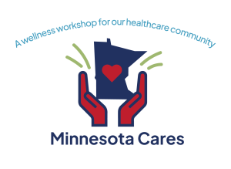

Your Invitation to Minnesota Cares: A Wellness Workshop for Our Healthcare Community

Members of the healthcare community in all fields and roles have given everything to serve Minnesotans throughout the unprecedented challenges of COVID-19. We know this has taken its toll on you and your families, yet your commitment and sacrifices have not wavered and you continue to care for us all. Minnesotans want to say thank you, and provide you with evidence-based tools to promote your ongoing wellness.

You and your healthcare colleagues from all disciplines are invited and encouraged to attend a FREE wellness workshop at the Minneapolis Convention Center October 7-8, 2022. You will learn proven ways to deal with stress, and techniques to strengthen long-term self-care. There will be three dynamic keynote speakers and a large number of breakout sessions. This event provides you a no-cost, low-stress way to try out many activities that support ongoing mental and physical health—yoga, art therapy, Zumba, HeartMath, building good habits, stress first aid, guided meditation, and many others. Come and enjoy yourself while you learn strategies to stay healthy.

There will be five sessions offered over two days to accommodate different shifts and work schedules. All sessions, parking, and snacks will be provided to you at no charge. What’s the catch? There is none--Minnesotans are grateful for your service and want to help you get new skills for your personal self-care toolbox.

The breakout sessions have three basic themes with goals for how the activities can help you recover and better take care of yourself going forward:
*Healing/Recovery
Activities that aid in recovery from stressful events
*Grounding/In the Moment Techniques
Activities that provide tools and techniques you can use on the job to re-set your autonomic nervous system so you can continue working while caring for yourself
*Strengthening Resilience
Activities that strengthen your capacity to deal with stressors over time

Mark your calendar, and prepare to invest in yourself!

