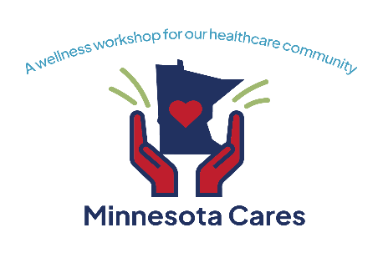

**“We are far enough into this pandemic to face the true reality there isn’t any more help coming. But the front line, the only line, still needs support and incentives to keep going. We need those in the position of power to see our humanity, recognize our limits and fill our cups so we can keep pouring from them.”**

*-Kelley Anaas, ICU nurse, testifying to the Minnesota Legislature*

Dear Minnesota Leader:

Our healthcare community has given selflessly to care for Minnesotans during the pandemic for more than two years, at great cost to their physical and mental health. Workers report being exhausted, overwhelmed, depressed, and anxious, and we are seeing shortages across nearly all job classes.

A number of current and former leaders in healthcare have donated their time and expertise to plan a FREE two-day event to honor the healthcare community and to provide them with evidence-based tools to improve their well-being and build resilience. Please see the attached detailed description of the event and the support needed from our community.

This event is open to anyone in the healthcare community (hospital, clinic, long-term care, pharmacy, emergency medical, public health, and many others) who provided care or support services during the pandemic. The event provides an opportunity to:

**THANK** the healthcare community for their past and ongoing service

**TEACH** self-care through a variety of workshops and learning sessions

**FOSTER RESILENCE** for the future through evidence-based strategies and tools

**How you can help:**

**BECOME A SPONSOR**

* Sponsorship levels are available from $250 to $20,000, with sponsor recognition in all materials

**PROVIDE IN-KIND SUPPORT**

* Donate gift cards, massages, gift bags, bus or van transportation, lodging, or many other items

**SUPPORT YOUR STAFF’S ATTENDANCE**

* Healthcare providers can also support this effort by giving staff time to attend and facilitating transportation and lodging

**Please support our healthcare community by sponsoring this vital event.**

Go to: <https://www.eventbrite.com/e/minnesota-cares-a-wellness-workshop-for-our-healthcare-community-tickets-367092903757>

Or Contact: [Christine.chell@hcmed.org](mailto:Christine.chell@hcmed.org) 612.743.3815

Thank you for securing a better future for the healthcare community we all depend on!

Chris Chell and Kerry Appleton on behalf of the Minnesota Cares Planning Committee

Endorsed by: Hennepin Healthcare, North Memorial Health, Arrowhead EMS Association