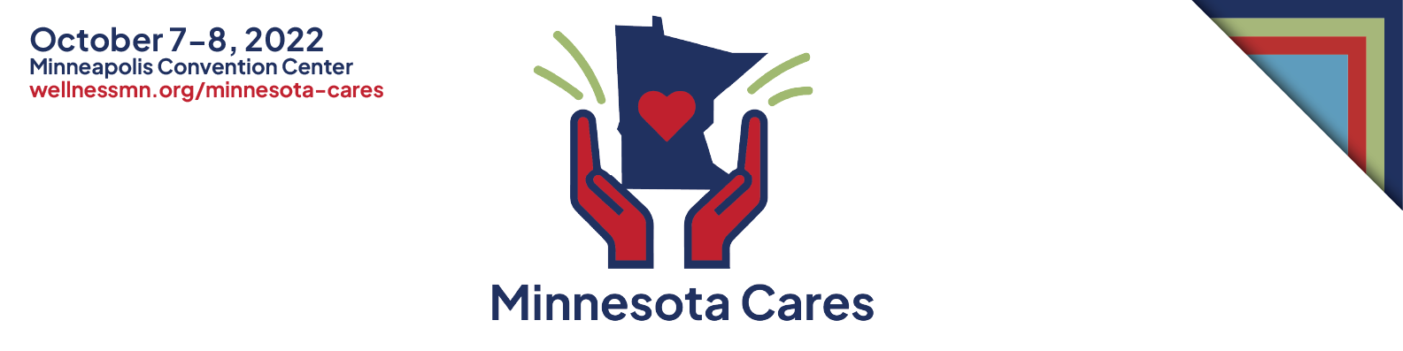

Toolkit: Social Media Posts

Please use these social posts and images to share and promote the MN Cares Workshop’s updates and information to your staff and encourage them to attend. We have provided pro-tips below to ensure the best possible exposure.

FACEBOOK, INSTAGRAM or LinkedIn:

-Calling all Minnesota Healthcare workers! Minnesota Cares is more than a conference; it is a special 2-day event that is designed to enrich the well-being and education of YOU, the healthcare community who give endlessly to all.
Register at wellnessmn.org/Minnesota-cares
#mncares2022 #wellnessmn #minnesotacaresworkshop #mncares #supporthealthcareworkers

-Since March 2020, you have consistently responded to care for us throughout the unprecedented challenges of COVID-19. We know your service and care has taken a tremendous toll on your well-being, yet you continue to provide care courageously and skillfully. This workshop’s goal is to offer well-deserved support and tools to nurture and sustain personal well-being to YOU, our HEALTHCARE HEROES!
Register at wellness.org/Minnesota-cares
#mncares2022 #wellnessmn #minnesotacaresworkshop #mncares #supporthealthcareworkers

-MN Cares is a workshop designed to assist with our healthcare worker’s well-being. It is a free 2-day event open to anyone in the healthcare community. The event will focus on evidence-based practices to help our healthcare heroes heal from the trauma of the pandemic response, build resilience, and participate in wellness activities to ongoing self-care.
Register at wellnessmn.org/Minnesota-cares
#mncares2022 #wellnessmn #minnesotacaresworkshop #mncares #supporthealthcareworkers

-Members of the healthcare community in all fields and roles have given everything to serve Minnesotans throughout the unprecedented challenges of COVID-19. We know this has taken its toll on them and their families, yet their commitment and sacrifices have not wavered, and they continue to care for us all. Minnesotans want to say thank you and provide the healthcare community with evidence-based tools to promote their ongoing wellness.
Please join us as we honor YOU, a vital part of Minnesota’s healthcare community.
Register at wellnessmn.org/Minnesota-cares
#mncares2022 #wellnessmn #minnesotacaresworkshop #mncares #supporthealthcareworkers

TWITTER:

-MN Cares Workshop is a big THANK YOU to our healthcare community for your past and ongoing care and service throughout the unprecedented pandemic.
Register at wellnessmn.org/Minnesota-cares
#mncares2022 #wellnessmn #minnesotacaresworkshop #mncares #supporthealthcareworkers

Please join us as we honor YOU, a vital part of Minnesota’s healthcare community.
Register at wellnessmn.org/Minnesota-cares
#mncares2022 #wellnessmn #minnesotacaresworkshop #mncares #supporthealthcareworkers

What will Minnesota Cares Workshop do?
THANK healthcare workers. TEACH self-care. Foster RESILIENCE.
Register at wellnessmn.org/Minnesota-cares
#mncares2022 #wellnessmn #minnesotacaresworkshop #mncares #supporthealthcareworkers

PRO TIPS
- The ideal post incorporates a visual along with text. Include one of the social graphics provided, or a picture or a video of your product, technology or technique in your post to get maximum engagement.
- Post new tweets regularly in the days and weeks leading up to the workshop. Increase frequency as the date gets nearer.
- Make sure to use the workshop hashtags: #mncares2022 #minnesotacaresworkshop #supportheathcareworkers #wellnessmn2022 #mncares
- Posting times:
  - The best times to post on social media overall is 10:00 AM on Tuesdays, Wednesdays, and Thursdays.
  - The best time to post on Facebook is 8:00 AM to 12:00 PM on Tuesdays and Thursdays.
  - The best time to post on Instagram is 11:00 AM on Wednesdays.
  - The best time to post on Twitter is 8:00 AM on Mondays and Thursdays.
  - The best time to post on LinkedIn is 9:00 AM on Tuesdays and Wednesday
Facebook Banner:
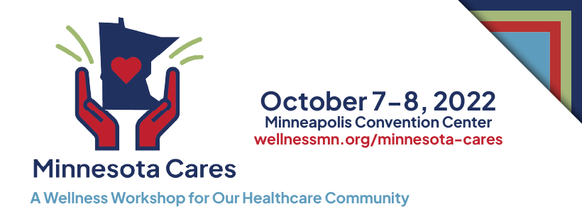

LinkedIn Banner:

Twitter Banner:
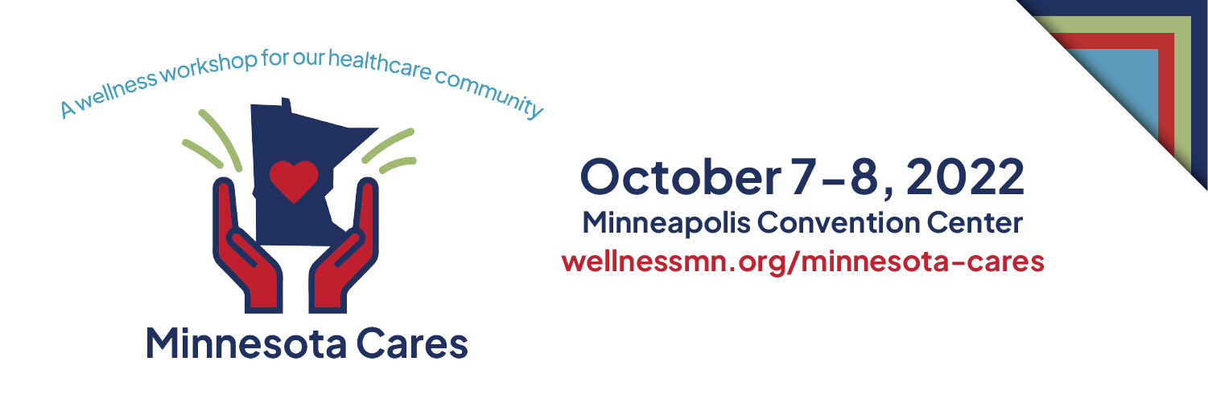

Images for social posts:
