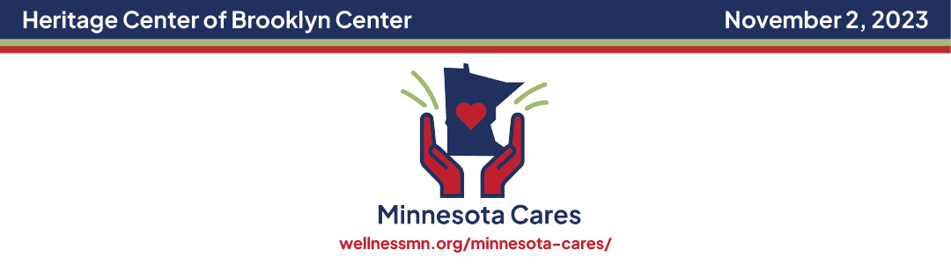

Toolkit: Social Media Posts
Please use these social posts and images to share and promote the MN Cares Workshop’s updates and information to your staff and encourage them to attend. We have provided pro-tips below to ensure the best possible exposure.

FACEBOOK, INSTAGRAM or LinkedIn:

-Calling all Minnesota Healthcare workers! Minnesota Cares is more than a conference; it is a special event that is designed to enrich the well-being and education of YOU, the healthcare community who give endlessly to all.
Register at https://aemsa.regfox.com/minnesota-cares-2023
#mncares2023 #wellnessmn #minnesotacaresworkshop #mncares #supporthealthcareworkers

-Minnesota’s Healthcare community has been strained for years, and the pandemic only exacerbated the challenges which continue today. As everyone is moving along through the new reality, support for our caregivers has never been more vital. Please join us as we honor YOU, a vital part of Minnesota’s healthcare community.
Register at https://aemsa.regfox.com/minnesota-cares-2023
mncares2023 #wellnessmn #minnesotacaresworkshop #mncares #supporthealthcareworkers

-In 2022, the first-ever Minnesota Cares Wellness Workshop was held to care for and encourage our health care community; it was a great success. We are pleased to announce the workshop will return in 2023 to continue its mission. This special event is designed to provide an inclusive space for our diverse healthcare community to identify a personal path toward healing, restoration, evidence-based learning, resilience, and fun as a “Thank You” to those who care for Minnesotans. The workshop will offer belonging, knowledge, and tools to nurture and sustain personal well-being in any healthcare role.
Register at https://aemsa.regfox.com/minnesota-cares-2023
mncares2023 #wellnessmn #minnesotacaresworkshop #mncares #supporthealthcareworkers

-This workshop’s goal is to offer well-deserved support and tools to nurture and sustain personal well-being to YOU, our HEALTHCARE HEROES!
Register at https://aemsa.regfox.com/minnesota-cares-2023
#mncares2023 #wellnessmn #minnesotacaresworkshop #mncares #supporthealthcareworkers

-MN Cares is a workshop designed to assist with our healthcare worker’s well-being. It is a free event open to anyone in the healthcare community. The event will focus on evidence-based practices to help our healthcare heroes build resilience, and participate in wellness activities to ongoing self-care.
Register at https://aemsa.regfox.com/minnesota-cares-2023
#mncares2023 #wellnessmn #minnesotacaresworkshop #mncares #supporthealthcareworkers

- Minnesotans want to say thank you and provide the healthcare community with evidence-based tools to promote their ongoing wellness.
Please join us as we honor YOU, a vital part of Minnesota’s healthcare community.
Register at https://aemsa.regfox.com/minnesota-cares-2023
#mncares2023 #wellnessmn #minnesotacaresworkshop #mncares #supporthealthcareworkers

TWITTER:

-MN Cares Workshop is a big THANK YOU to our healthcare community for your past and ongoing care
Register at https://aemsa.regfox.com/minnesota-cares-2023
#mncares2023 #wellnessmn #minnesotacaresworkshop #mncares #supporthealthcareworkers

Please join us as we honor YOU, a vital part of Minnesota’s healthcare community.
Register at https://aemsa.regfox.com/minnesota-cares-2023
#mncares2023 #wellnessmn #minnesotacaresworkshop #mncares #supporthealthcareworkers

What will Minnesota Cares Workshop do?
THANK healthcare workers. TEACH self-care. Foster RESILIENCE.
Register at https://aemsa.regfox.com/minnesota-cares-2023
#mncares2023 #wellnessmn #minnesotacaresworkshop #mncares #supporthealthcareworkers

PRO TIPS
- The ideal post incorporates a visual along with text. Include one of the social graphics provided, or a picture or a video of your product, technology, or technique in your post to get maximum engagement.
- Post new tweets regularly in the days and weeks leading up to the workshop. Increase frequency as the date gets nearer.
- Make sure to use the workshop hashtags: #mncares2023 #minnesotacaresworkshop #supportheathcareworkers #wellnessmn2023 #mncares
- Posting times:
  - The best times to post on social media overall is 10:00 AM on Tuesdays, Wednesdays, and Thursdays.
  - The best time to post on Facebook is 8:00 AM to 12:00 PM on Tuesdays and Thursdays.
  - The best time to post on Instagram is 11:00 AM on Wednesdays.
  - The best time to post on Twitter is 8:00 AM on Mondays and Thursdays.
  - The best time to post on LinkedIn is 9:00 AM on Tuesdays and Wednesday
Facebook Banner:

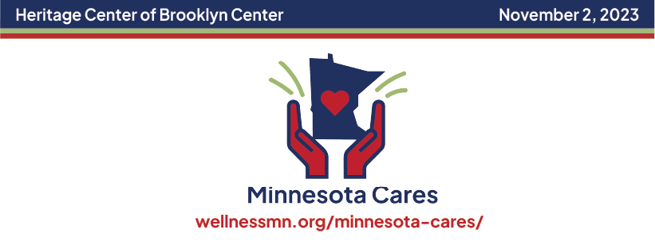

LinkedIn Banner:
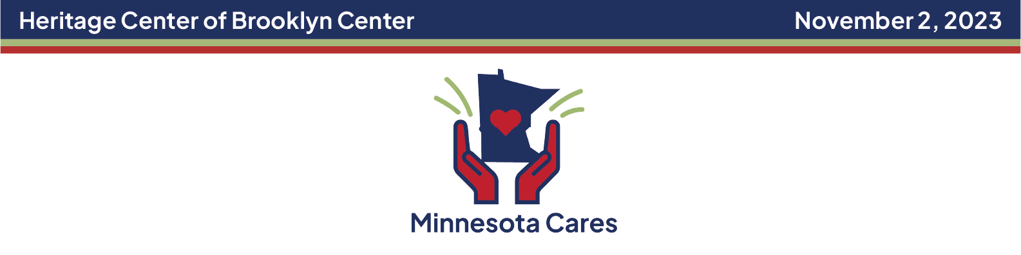

Twitter Banner:
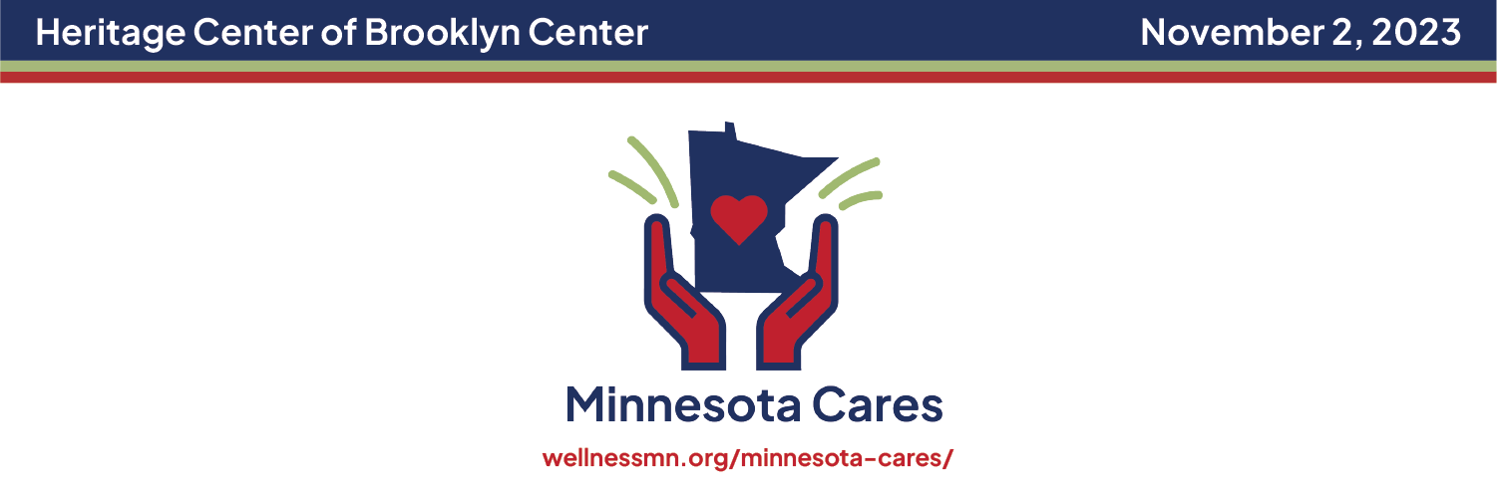

Images for social posts:
